Variant Look-Up: Rs2268616, chr2:218260234, Rs11115199, Rs148793499

1) Rs2268616

LDlink:

|  |  |  |  |  |  |  |  |  |  |  |
| --- | --- | --- | --- | --- | --- | --- | --- | --- | --- | --- |
| **RS Number** | **Position (GRCh37)** | **R2** | **D'** | **Gene Symbol** | **Gencode ID** | **Tissue** | **Non-effect Allele Freq** | **Effect Allele Freq** | **Effect Size** | **P-value** |
| [rs2268616](https://www.ncbi.nlm.nih.gov/snp/rs2268616) | chr14:75419444 | 1.0 | 1.0 | [LTBP2](https://www.ncbi.nlm.nih.gov/gene/4053) | [ENSG00000119681.11](https://ensembl.org/Homo_sapiens/Gene/Summary?g=ENSG00000119681) | [Skin - Not Sun Exposed (Suprapubic)](https://www.gtexportal.org/home/eqtls/tissue?tissueName=Skin_Not_Sun_Exposed_Suprapubic) | A=0.98 | G=0.02 | [-0.341](https://www.gtexportal.org/home/snp/rs2268616) | [8x10-5](https://www.gtexportal.org/home/snp/rs2268616) |
| [rs61757880](https://www.ncbi.nlm.nih.gov/snp/rs61757880) | chr14:75419928 | 0.746 | 1.0 | [PGF](https://www.ncbi.nlm.nih.gov/gene/5228) | [ENSG00000119630.13](https://ensembl.org/Homo_sapiens/Gene/Summary?g=ENSG00000119630) | [Cells - Cultured fibroblasts](https://www.gtexportal.org/home/eqtls/tissue?tissueName=Cells_Cultured_fibroblasts) | C=0.985 | T=0.015 | [0.545](https://www.gtexportal.org/home/snp/rs61757880) | [2x10-4](https://www.gtexportal.org/home/snp/rs61757880) |

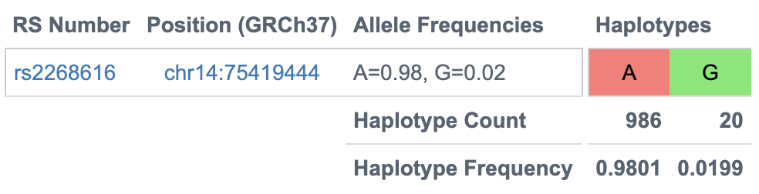

RegulomeDB:

* ChIP data: liver, kidney, blood, bodily fluid, embryo -> KDM1A target
* 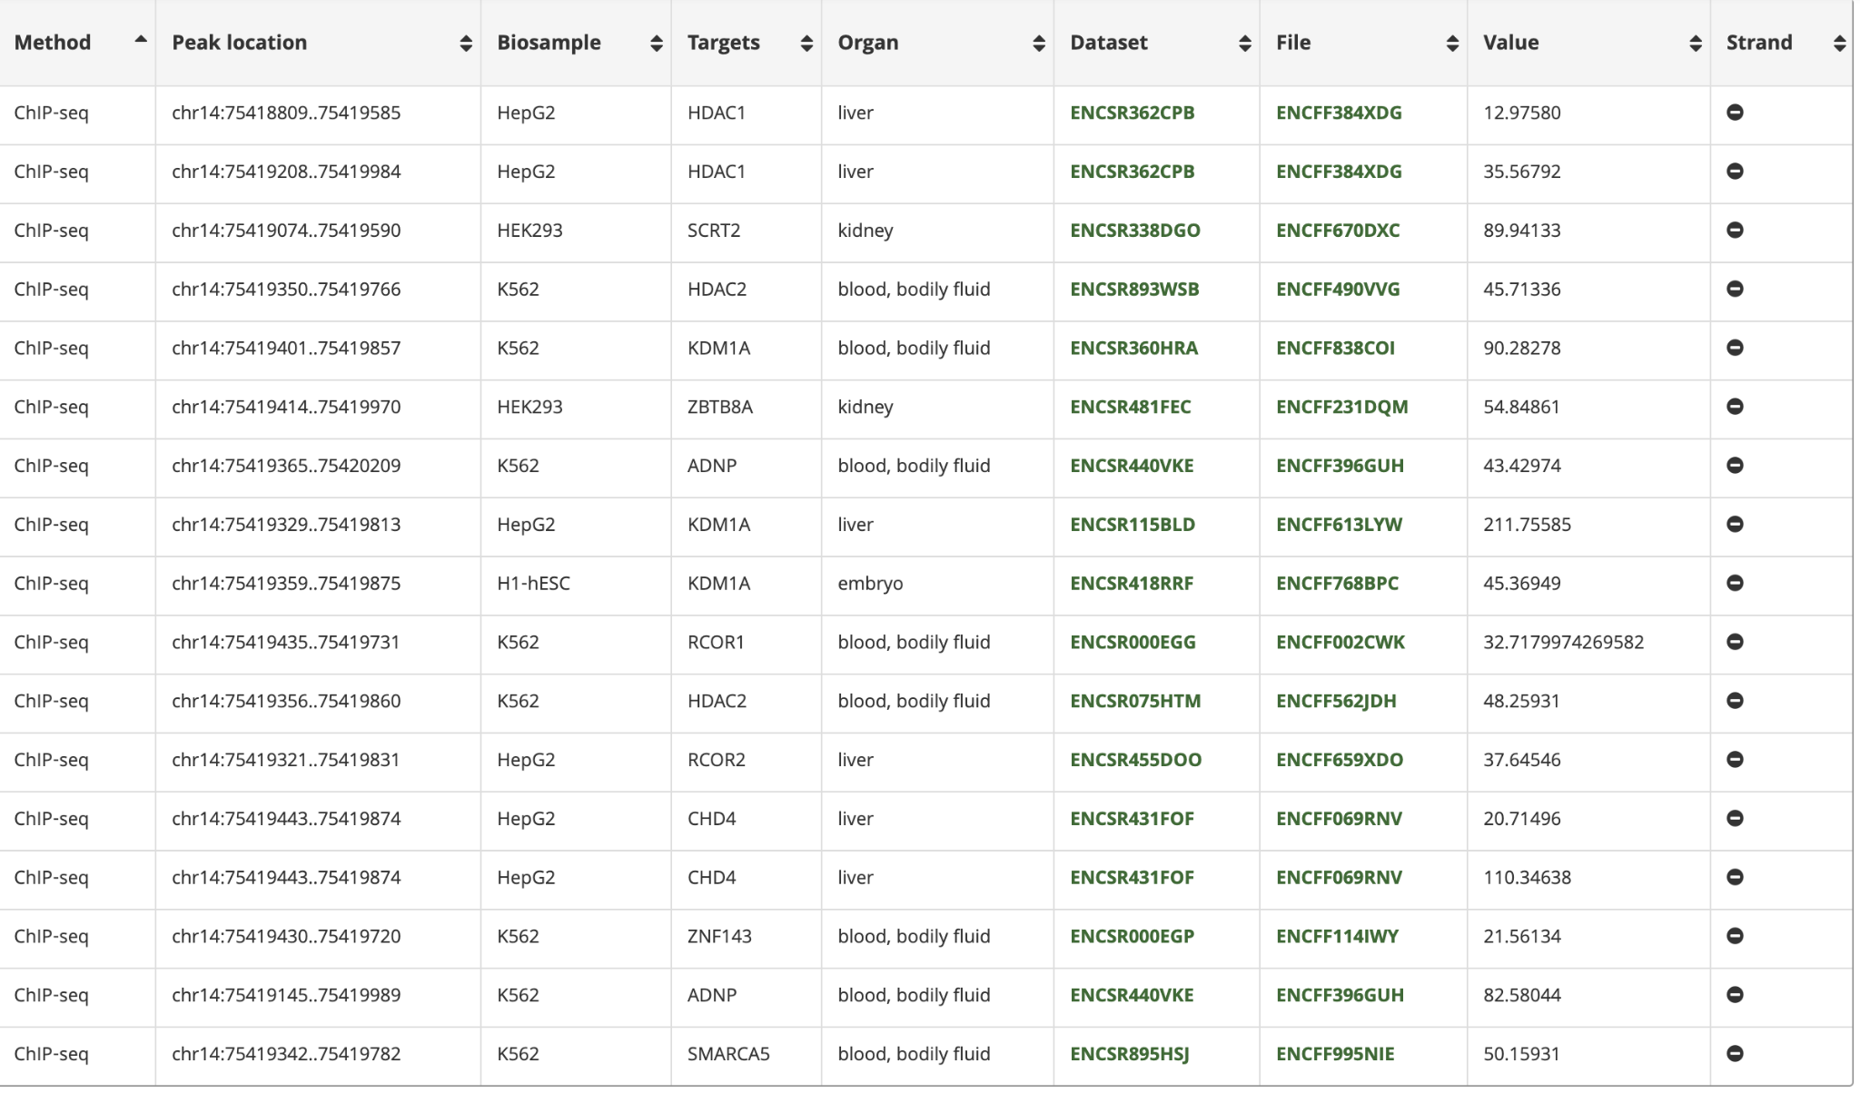
* Chromatin State
  + **Strong transcription**: placenta, endothelial cell of umbilical vein, keratinocyte… lung, heart left ventricle, aorta, astrocyte, spleen, B-cell…
  + **Enhancer**: stomach, small intestine, lung, mesenchymal stem cell…
  + **Repressed PolyComb (i.e. epigenetic silencing of genes)**: duodenum muscle layer, T-cell, subcutaneous abdominal adipose tissue...CD14-positive monocyte, CD4-positive helper T cell, fibroblast of lung, CD8-positive alpha-beta memory T-Cell
* Accessibility via DNase-seq experiments
  + T-helper 1 cell; organ = blood, bodily fluid
  + Islet of Langerhans; organ = pancreas
  + Placenta
  + Tibial artery, pancreas, embryo

2) 2:218260234_AC_A

LDlink:

|  |  |  |  |  |  |  |  |  |  |  |
| --- | --- | --- | --- | --- | --- | --- | --- | --- | --- | --- |
| **RS Number** | **Position (GRCh37)** | **R2** | **D'** | **Gene Symbol** | **Gencode ID** | **Tissue** | **Non-effect Allele Freq** | **Effect Allele Freq** | **Effect Size** | **P-value** |
| [rs11684856](https://www.ncbi.nlm.nih.gov/snp/rs11684856) | chr2:218305664 | 0.197 | 0.874 | [GPBAR1](https://www.ncbi.nlm.nih.gov/gene/151306) | [ENSG00000179921.14](https://ensembl.org/Homo_sapiens/Gene/Summary?g=ENSG00000179921) | [Muscle - Skeletal](https://www.gtexportal.org/home/eqtls/tissue?tissueName=Muscle_Skeletal) | C=0.937 | G=0.063 | [0.312](https://www.gtexportal.org/home/snp/rs11684856) | [4x10-5](https://www.gtexportal.org/home/snp/rs11684856) |
| [rs10490755](https://www.ncbi.nlm.nih.gov/snp/rs10490755) | chr2:218677659 | 0.130 | 0.688 | [GPBAR1](https://www.ncbi.nlm.nih.gov/gene/151306) | [ENSG00000179921.14](https://ensembl.org/Homo_sapiens/Gene/Summary?g=ENSG00000179921) | [Skin - Sun Exposed (Lower leg)](https://www.gtexportal.org/home/eqtls/tissue?tissueName=Skin_Sun_Exposed_Lower_leg) | G=0.941 | A=0.059 | [0.282](https://www.gtexportal.org/home/snp/rs10490755) | [1x10-4](https://www.gtexportal.org/home/snp/rs10490755) |

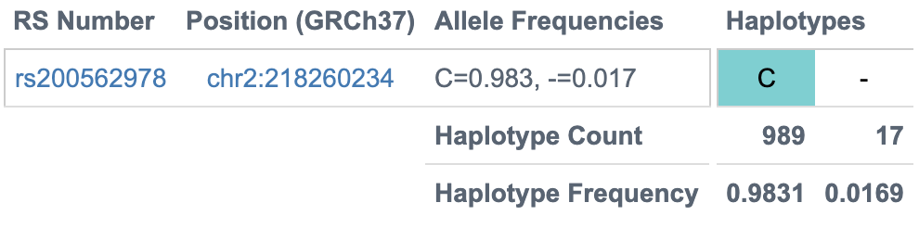

RegulomeDB: none found

3) Rs11115199

|  |  |  |  |  |  |  |  |  |  |  |
| --- | --- | --- | --- | --- | --- | --- | --- | --- | --- | --- |
| **RS Number** | **Position (GRCh37)** | **R2** | **D'** | **Gene Symbol** | **Gencode ID** | **Tissue** | **Non-effect Allele Freq** | **Effect Allele Freq** | **Effect Size** | **P-value** |
| [rs139327292](https://www.ncbi.nlm.nih.gov/snp/rs139327292) | chr12:82047697 | 0.262 | 0.532 | [METTL25](https://www.ncbi.nlm.nih.gov/gene/84190) | [ENSG00000127720.7](https://ensembl.org/Homo_sapiens/Gene/Summary?g=ENSG00000127720) | [Artery - Tibial](https://www.gtexportal.org/home/eqtls/tissue?tissueName=Artery_Tibial) | T=0.987 | A=0.013 | [-0.492](https://www.gtexportal.org/home/snp/rs139327292) | [2x10-4](https://www.gtexportal.org/home/snp/rs139327292) |
| [rs79719968](https://www.ncbi.nlm.nih.gov/snp/rs79719968) | chr12:82496673 | 0.176 | 0.849 | [METTL25](https://www.ncbi.nlm.nih.gov/gene/84190) | [ENSG00000127720.7](https://ensembl.org/Homo_sapiens/Gene/Summary?g=ENSG00000127720) | [Lung](https://www.gtexportal.org/home/eqtls/tissue?tissueName=Lung) | G=0.945 | A=0.055 | [-0.220](https://www.gtexportal.org/home/snp/rs79719968) | [3x10-5](https://www.gtexportal.org/home/snp/rs79719968) |

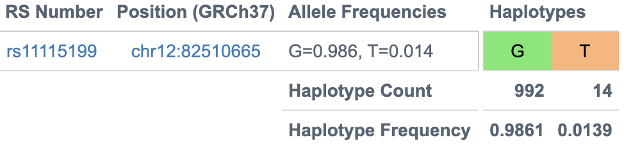

RegulomeDB search:

* Chromatin state: **Heterochromatin** (vasculatore, lung, body skin), **Strong transcription** (mesendoderm), **Quiescent/Low** (T cells- CD8-positive, alpha-beta memory T cell, B cell...)
* 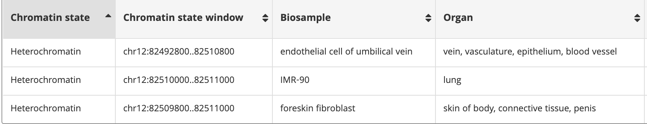
* 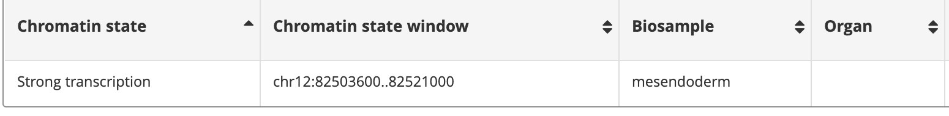
* Accessibility via DNase-seq experiments:
  + Peyer’s patch, organ = lymphoid tissue, intestine
  + dermis blood vessel endothelial cell, organ = epithelium, vasculatore, blood vessel, body skin
  + Naive B cell
  + Placenta and tibial nerve

4) Rs148793499

LDLink:

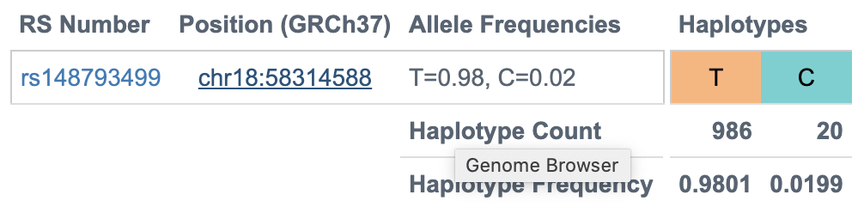

RegulomeDB:

* Chromatin State
  + Strong transcription = mesendoderm
  + Enhancer = uterus
  + Repressed polycomb = lymph, body skin (connective tissue)
  + quiescent/low: CD14-positive monocyte, lung fibroblast, small intestine, embryo